# Toureter Interpreter

——**Interpretive Execution Design Document**

**Written by Xiaoran Zhan**

# Produced by Toureter Group

**All Rights Reserved, Copy Reserved**

目录

Toureter Interpreter 0

Produced by Toureter Group 0

1 整体概述 3

2 实现概念介绍 3

2.1 语法分析对象介绍 3

2.1.1 CMM语言简介 3

2.3 总体流程图 5

2.4拓展CMM语法规则总结 6

2.4.1 程序 6

2.5 基本逻辑解释 8

2.5.1 声明（定义）语句逻辑 8

2.5.2 赋值语句逻辑 9

2.5.3 循环语句逻辑 10

2.5.4 条件语句 11

2.5.5 读语句 12

2.5.6 写语句 13

2.5.7 计算表达式、分表达式、子表达式的值 13

3 实现方法介绍 13

3.1 所需结构 13

3.1.1 符号类结构—超类 13

3.1.2四种符号类结构 14

3.1.3 符号表结构 15

3.1.4 四元式类结构 17

} 21

3.1.5 设置下一个Token，移动token的方法 21

3.1.6 在符号表中查找特定符号并返回该符号的地址 21

3.1.7 在符号表中查找元素 23

3.1.8 用于计算表达式值的两个函数 23

3.2 具体实现 25

3.2.1 分析入口 25

3.2.2 程序由类和结构体构成 26

3.2.3 单条语句 27

3.2.4 语句序列 28

3.2.5 声明语句 28

3.2.6 表达式 29

3.2.7 运算表达式 30

3.2.8 分表达式 31

3.2.9 返回语句 31

3.2.10 循环语句 32

3.2.11 条件语句 32

3.2.12 布尔表达式 33

3.2.13 读语句 35

3.2.14 写语句 35

3.2.15 赋值语句 37

4 实例展示 38

4.1 无参数类展示 38

4.2 有参数类展示 40

# 1 整体概述

Toureter Interpreter解释执行模块的主要功能是对语法树进行遍历,分析语义、生成中间代码，同时用解释器执行中间代码。

# 2 实现概念介绍

## 2.1 拓展CMM语法简介

词法分析的对象是CMM语言的源程序，源程序的叙述如下：

CMM语言为C语言的一个子集：

* + 语言结构：顺序结构（赋值语句、输入、输出）、选择语句（if-else）、循环结构（while）。这些语句结构和C语言的结构一样，允许嵌套。
  + 表达式局限于关系表达式和算术表达式，运算的优先级为：算术运算、关系运算，并服从左结合规则。
  + 算术表达式包括整数和实数上的运算、变量以及“（）”、“*”、“+”、“-”、“/”，运算符的优先级顺序为：“（）”大于“*”和“/”大于“+”和“-”。
  + 关系运算符包括：“<”、“==”、“<>”。
  + 一条语句以“；”结束；程序由一条语句或者由“{”和“}”嵌套表达的复合语句。
  + 支持多行注释（使用“/*”和“ */ ”）
  + 支持数组运算，数组的下标必须是正整数，使用“[”和“]”表示数组下标。
  + 变量的使用之前需要先声明，声明的方式和C语言一样。

|  |  |  |
| --- | --- | --- |
| 保留字 | 特殊符号 | 其他 |
| if | + | 十进制的整数与实数 |
| else | - |
| while | * |
| read | / | 标识符（由数字、字母和下划线组成的串，但必须以字母开头、且不能以下划线结尾的串） |
| write | = |
| int | < |
| real | == |  |
| struct | <> |  |
| class | ( |  |
|  | ) |  |
|  | ; |  |
|  | { |  |
|  | } |  |
|  | /* |  |
|  | */ |  |
|  | [ |  |
|  | ] |  |
|  | /* |  |
|  | */ |  |
|  | && |  |
|  | || |  |
|  | ! |  |

经过词法分析，得到的符号类型简介如下：

|  |  |
| --- | --- |
| 符号类型 | 符号 |
| Keyword | if，else，while，int，real，read，write |
| Sign | +，-，*，/，/*，*/，=，==，<，<>，[，]，(，)，{，}，;，,， |
| int | 十进制整数，由数字串组成 |
| real | 十进制实数，由数字和小数点组成 |
| Identifier | 由字母开头，由数字、字母和_组成，并且不以下划线结尾的字符串 |

## 2.3 总体流程图

词法分析的总体流程图如下图所示：

## 2.4拓展CMM语法规则总结

**注意: 大写字母为非终结符(Nonterminal), 小写为终结符(Terminal),有颜色的字体为保留字或者运算符.语法用BNF范式表示**

### 2.4.1 程序

程序由class和struct组成

Program ->( class|struct)*

* + 1. **类**

CLASS-> class identifier { (DECLARE_STMT |FUNCTION)* } //类定义由ID和声明语句,函数组合而成

* + 1. **结构体**

STRUCT-> struct identifier { (DECLARE_STMT)* } //结构体由ID和声明语句组成

* + 1. **函数**

FUNCTION-> TYPE identifier (( DECLARE_STMT)*) STMT_SEQUENCE

* + 1. **语句序列**

STMT_SEQUENCE -> { STATEMENT}* // 语句序列由多条语句组成

* + 1. **语句**

STATEMENT-> ASSGIN_STMT|

WRITE_STMT |

READ_STMT |

IF_STMT |

WHILE_STMT |

DECLARE_STMT|

CALL_STMT

* + 1. **循环语句**

WHILE_STMT -> while ( EXPR* ) ({ STMT_SEQUENCE})|(STATEMENT) //while语句

* + 1. **赋值语句**

ASSGIN_STMT -> identifier = EXPR

identifier -> identifier (“[“ EXPR“]” )*

* + 1. **条件语句**

If_STMT -> if ( EXPR* ) ({ STMT_SEQUENCE})|(STMT) (else ({STMT_SEQUENCE})|(STATEMENT))?

* + 1. **读语句**

READ_STMT -> read identifier; //读语句

* + 1. **写语句**

WRITE_STMT -> write EXPR; //写语句

* + 1. **表达式语句**

EXPR->LOGIC_AND_EXPR

LOGIC_AND_EXPR -> LOGIC_OR_EXPR (&& LOGIC_OR_EPXR)?

LOGIC_OR_EXPR ->LOGIC_NOT_EXPR (|| LOGIC_NOT_EXPR)?

LOGIC_NOT_EXPR ->(!)? LOGIC_ELEMENT_EXPR

LOGIC_ELEMENT_EXPR-> true|false|EQUALITY_EXPR

EQUALITY_EXPR -> ARITHM_EXPR (<|<=|>|>=|==|<> ARITHM_EXPR)?

ARTHM_EXPR ->TERM_EXPR (+|- TERM_EXPR)?

TERM_EXPR ->UNARY_EXPR (*|/|% UNARY_EXPR)?

UNARY_EXPR ->(-)? ELMENT

ELMENT -> const|CALL_STMT|identifier|(EXPR)

## 2.5 基本逻辑解释

### 2.5.1 声明（定义）语句逻辑

从根节点进行扫描

下一个token是不是“[”

搜索数组符号表，查看是否有当前level的ident定义过

搜索普通变量符号表，查看是否有当前level的ident定义过

是否定义过？

是

否

忽略此次定义，并报错

将该ident连同后面扫描得到的值加入到符号表中

是

否

多个变量声明要考虑“，”的情况，将，作为每一次定义结束的判断条件，如果有“，”则说明新的变量声明，进行相同的操作即可。

### 2.5.2 赋值语句逻辑

扫描到ident，暂时存储

否

搜索普通变量符号表，查看是否有当前level的ident定义过

下一个token是不是“[”

是

获取下一个token，并且一同与ident在数组符号表中搜索

是否定义过？

否

是

将=后面的值赋值给相应的符号表并进行保存

报错，提醒用户越界或未定义的符号

### 2.5.3 循环语句逻辑

扫描“(”后直到条件符号位置，并进行保存

获取下一个token，并进行保存，这个token是条件比较符号

扫描“)”前，并将扫描结果进行保存进行保存，并保存此时ptr的结果

计算并保存while循环结束的ptr的位置，以防止while循环一次都不执行带来的后果

是

根据保存得知计算表达式是否成立

否

退出

While循环执行的成败在于首先判断while结束的地址，之后保存相关的信息进行循环计算，如果布尔表达式成立则执行，如果不成立则调到之前保存的ptr处进行执行。

### 2.5.4 条件语句

计算并保存布尔表达式中的值和比较符号

根据保存得知比较表达式是否成立

是

执行if语句

否

根据下一个token判断是否有else语句

跳过所有if语句的内容

否

是

根据下一个token判断是否有else语句

跳过所有else语句

否

是

结束

执行else语句

If语句执行的关键在于如何跳过不执行的语句，并且判断在没有else的情况下的解释执行过程。

### 2.5.5 读语句

保存read()括号中的内容

读取输入框中的内容

解析read()括号内的内容

否

在符号表中检查是否存在

报错，并提示用户进行修改

是

解析read()括号内的内容并在符号表中检查是否存在

### 2.5.6 写语句

保存write()括号中的内容

否

在符号表中检查是否存在

报错，程序终止，提醒用户

是

输出操作

### 2.5.7 计算表达式、分表达式、子表达式的值

判断现在计算的对象是int还是real，并选择不同的函数进行计算

再调用结束的时候统一进行计算

# 3 实现方法介绍

## 3.1 所需结构

### 3.1.1 符号类结构—超类

internal enum SymbolType { VOID, STRUCT, ARRAY, FUNCTION, BOOLEAN, INT, REAL }

internal class Symbol

{

private string m_offset = "";

public string Name { get; set; }

public SymbolType Type{ get; set; }

public string Address { get { return this.m_offset; } set { this.m_offset = value; } }

public GrammerTreeNode OrginNode { get; set; }

}

### 3.1.2四种符号类结构

internal class FunctionSymbol : Symbol {

private List<Symbol> m_params = new List<Symbol>();

public SymbolType ReturnType { get { return ReturnValue.Type;} }

public Symbol ReturnValue { get; set; }

public List<Symbol> Parameter { get { return m_params; } set { this.m_params = value; } }

public FunctionSymbol() { }

}

internal class VarSymbol : Symbol {

public GrammerTreeNode InitValueExpr { get; set; }

}

internal class StructSymbol : Symbol

{

private List<Symbol> m_children = new List<Symbol>();

public string StructName { get; set; }

public List<Symbol> Children

{

get { return this.m_children; }

set { this.m_children = value; }

}

public StructSymbol() {

}

public int GetIndexByChildName(string name)

{

return this.m_children.IndexOf(m_children.Find(c => c.Name == name));

}

public Symbol GetSymbolByName(string name)

{

return this.m_children.Find(c => c.Name == name);

}

}

internal class ArraySymbol : Symbol {

private List<int> m_dimensionSize=new List<int>();

public SymbolType ArrayType { get; set; }

public int Dimension { get; set; }

public Symbol Element { get; set; }

}

### 3.1.3 符号表结构

internal sealed class SymbolTable:Dictionary<string,Symbol> {

private const string ENTRANCE = "Main";

private SymbolTable m_subTable;

private SymbolTable m_supTable;

private FunctionSymbol m_entrance;

public SymbolTable SupTable {

get { return this.m_supTable; }

set { this.m_supTable = value; }

}

public SymbolTable SubTable {

get { return this.m_subTable; }

set { this.m_subTable = value; }

}

public FunctionSymbol Entrance { get { return this.m_entrance; } }

public SymbolTable() {

}

public void Add(Symbol symbol){

Add(symbol.Name, symbol);

}

public new void Add(string name,Symbol symbol) {

if (!this.ContainsInThisScope(name))

base.Add(name, symbol);

else

throw new DuplicatedDeclareException(symbol.OrginNode.Children[1].TerminalType);

}

public void AddFunction(FunctionSymbol funcSymbol) {

this.Add(funcSymbol);

if (funcSymbol.Name == ENTRANCE)

this.m_entrance = funcSymbol;

}

public bool Contains(string name) {

if (this.ContainsKey(name))

return true;

else if (this.m_supTable != null)

return this.m_supTable.Contains(name);

else return false;

}

public Symbol Find(Token token) {

if (this.ContainsKey(token.Image))

return this[token.Image];

else if (this.m_supTable != null)

return this.m_supTable.Find(token);

else

throw new UnDeclaredTypeException(token);

}

public FunctionSymbol GetFunctionSymbol(Token functionName, List<Token> paramTokens,List<Symbol> paramSymbols) {

if (this.ContainsKey(functionName.Image))

{

FunctionSymbol funSymbol = (FunctionSymbol)this[functionName.Image];

if (paramTokens.Count() != funSymbol.Parameter.Count)

throw new UnMatchedParametersException(functionName, paramTokens);

for (int i = 0; i < paramSymbols.Count; i++)

{

if (paramSymbols[i].Type != funSymbol.Parameter[i].Type)

throw new UnMatchedParametersException(functionName, paramTokens[i]);

}

return funSymbol;

}

else

throw new UnDeclaredTypeException(functionName);

}

public Symbol GetMembeSymbol(string structTypeName, GrammerTreeNode memberNode, out int offset) {

if (this.ContainsKey(structTypeName))

{

StructSymbol symbol =(StructSymbol) this[structTypeName];

Symbol memberSymbol = null;

if ((memberSymbol = symbol.Children.Find(c => c.Name == memberNode.TerminalType.Image && c.Type == SemanticAnalyzer.CastNodeToSymbolType(memberNode))) == null)

throw new UnMatchedMemberException(memberNode.TerminalType, symbol);

else

{

offset = symbol.Children.IndexOf(memberSymbol);

return memberSymbol;

}

}

else if (this.m_supTable != null)

{

return this.m_supTable.GetMembeSymbol(structTypeName, memberNode, out offset);

}

else

throw new Exception(string.Concat("找不到定义为", structTypeName, "的类型,异常在FindDefinition中发生"));

}

public FunctionSymbol GetEntranceFncSymbol()

{

if (this.Entrance == null)

if (this.m_supTable == null)

throw new SemanticException("缺少Main函数, 没有找到代码入口");

else

return this.m_supTable.GetEntranceFncSymbol();

else

return this.Entrance;

}

public bool ContainsInThisScope(string name) {

return (base.ContainsKey(name));

}

public Symbol FindInThisScopr(string name) {

if (this.ContainsInThisScope(name))

return this[name];

else return null;

}

}

### 3.1.4 四元式类结构

internal sealed class Quaternion

{

#region Quaternion command

public const string MALLOC = "MALLOC";

public const string COPY = "COPY";

public const string HOLD = "HOLD";

public const string PUSH = "PUSH";

public const string LOAD = "LOAD";

public const string OFFSET = "OFFSET";

public const string ADD = "ADD";

public const string SUB = "SUB";

public const string MUL = "MUL";

public const string DIV = "DIV";

public const string MOD = "MOD";

public const string GT = "GT";

public const string LT = "LT";

public const string GOE = "GOE";

public const string LOE="LOE";

public const string EQ = "EQ";

public const string NEQ = "NEQ";

public const string AND = "AND";

public const string OR = "OR";

public const string XOR = "XOR";

public const string MINUS = "MIS";

public const string NOT = "NOT";

public const string NEXT = "NEXT";

public const string JUMP = "JUMP";

#endregion

#region quaternion const

public const string OBJ = "OBJ";

public const string LIS = "LIS";

public const string INT = "INT";

public const string REAL = "REAL";

public const string BYVAL = "VAL";

public const string BYREF = "REF";

public const string STACK = "STACK";

public const string EAX = "EAX";

public const string EBX = "EBX";

public const string ECX = "ECX";

public const string EDX = "EDX";

public const string PC = "PC";

public const string EBP = "EBP";

#endregion

public const string STK_ADDR_PREFIX = "STK_";

public const string STK_ADDR_SEPERATOR = "_";

public const string STK_BOTTOM = "STK_0";

public const int REG_COUNT = 5;

#region debug info region

public const string DEBUG_HEAD = "//";

public const string DEBUG_varDeclareGenerate = "";

public const string DEBUG_functionGenerate = "";

public const string DEBUG_generateTypeCheckAndConvert = "";

public const string DEBUG_generateExpression = "";

public const string DEBUG_generateCalcElementAddress = "";

public const string DEBUG_saveContext = "";

public const string DEBUG_convertVarType = "";

public const string DEBUG_CastTokenTypeToSymbolType = "";

private static string debug_Address = STK_BOTTOM;

#endregion

public readonly static string[] LOGI_OPERATORS =new string[] { AND, OR, XOR };

public readonly static string[] COMP_OPERATORS = new string[] { EQ, NEQ, GT, LT, GOE, LOE };

public readonly static string[] NUM_OPERATORS = new string[] { ADD, SUB, MUL, DIV, MOD };

private const string SPACE = " ";

public enum AddressType{StackAddr,RegisterAddr,CodeAddr}

public string Value { get; private set; }

public Quaternion(params string[] quaters) {

this.Value = quaters[0];

for (int i = 1; i < quaters.Length; i++) {

this.Value=string.Concat(this.Value, SPACE, quaters[i]);

}

if (quaters[0] == Quaternion.MALLOC)

this.Value=string.Concat(this.Value, SPACE, DEBUG_HEAD, debug_Address);

}

public static string AddrIncrease(ref string address) {

if (address.StartsWith(STK_ADDR_PREFIX))

{

address=string.Concat(STK_ADDR_PREFIX, Convert.ToInt32(address.Split(STK_ADDR_SEPERATOR.ToArray())[1])+1);

debug_Address = address;

return string.Concat(STK_ADDR_PREFIX, Convert.ToInt32(address.Split(STK_ADDR_SEPERATOR.ToArray())[1])-1);

}

else if (address == EDX)

return ECX;

else

return "0";

public static string CreateStackAddr(int offset) {

return string.Concat("STK_", offset);

}

public static AddressType GetAddrTypeFromAddr(string addr) {

if (addr.StartsWith(STK_ADDR_PREFIX)|| addr=="")

return AddressType.StackAddr;

else if (new string[] { EAX, EBX, ECX, EDX }.Contains(addr))

return AddressType.RegisterAddr;

else

return AddressType.CodeAddr;

}

public static string GetQuaternionTypeFromSymbolType(SymbolType type) {

switch (type) {

case SymbolType.BOOLEAN:

case SymbolType.INT: return INT;

case SymbolType.REAL: return REAL;

case SymbolType.ARRAY:

case SymbolType.STRUCT: return LIS;

default: //TODO: DELETE

throw new Exception("卧槽,GetQuaternionTypeFromSymbolType接收到错误的参数了");

}

}

public static string GetUnaryOperatorByOperatorNode(GrammerTreeNode operatorNode) {

switch (operatorNode.TerminalType.Kind) {

case TokenKind.MINUS: return Quaternion.MINUS;

case TokenKind.NOT: return Quaternion.NOT;

default: //TODO:DELETE

throw new Exception("卧槽,操作符错误!快debug一下");

}

}

public static string GetBinoOperatorByOperatorNode(GrammerTreeNode operatorNode) {

switch (operatorNode.TerminalType.Kind)

{

case TokenKind.AND: return Quaternion.AND;

case TokenKind.OR: return Quaternion.OR;

case TokenKind.PLUS: return Quaternion.ADD;

case TokenKind.MINUS: return Quaternion.SUB;

case TokenKind.MOD: return Quaternion.MOD;

case TokenKind.MULTIPLY: return Quaternion.MUL;

case TokenKind.DIVIDE: return Quaternion.DIV;

case TokenKind.EQ: return Quaternion.EQ;

case TokenKind.NEQ: return Quaternion.NEQ;

case TokenKind.GOE: return Quaternion.GOE;

case TokenKind.LOE: return Quaternion.LOE;

case TokenKind.LT: return Quaternion.LT;

case TokenKind.GT: return Quaternion.GT;

default://TODO DELETE

throw new Exception("卧槽,操作符错误!快debug一下");

}

}

}

### 3.1.5 作用域的实现

public Symbol Find(Token token) { //向上遍历,查看父表中有无该元素

if (this.ContainsKey(token.Image))

return this[token.Image];

else if (this.m_supTable != null)

return this.m_supTable.Find(token);

else

throw new UnDeclaredTypeException(token);

}

### 3.1.6 在符号表中查找特定符号并返回该符号的地址

public Symbol Find(Token token) {

if (this.ContainsKey(token.Image))

return this[token.Image];

else if (this.m_supTable != null)

return this.m_supTable.Find(token);

else

throw new UnDeclaredTypeException(token);

}

public FunctionSymbol GetFunctionSymbol(Token functionName, List<Token> paramTokens,List<Symbol> paramSymbols) {

if (this.ContainsKey(functionName.Image))

{

FunctionSymbol funSymbol = (FunctionSymbol)this[functionName.Image];

if (paramTokens.Count() != funSymbol.Parameter.Count)

throw new UnMatchedParametersException(functionName, paramTokens);

for (int i = 0; i < paramSymbols.Count; i++)

{

if (paramSymbols[i].Type != funSymbol.Parameter[i].Type)

throw new UnMatchedParametersException(functionName, paramTokens[i]);

}

return funSymbol;

}

else

throw new UnDeclaredTypeException(functionName);

}

public Symbol GetMembeSymbol(string structTypeName, GrammerTreeNode memberNode, out int offset) {

if (this.ContainsKey(structTypeName))

{

StructSymbol symbol =(StructSymbol) this[structTypeName];

Symbol memberSymbol = null;

if ((memberSymbol = symbol.Children.Find(c => c.Name == memberNode.TerminalType.Image && c.Type == SemanticAnalyzer.CastNodeToSymbolType(memberNode))) == null)

throw new UnMatchedMemberException(memberNode.TerminalType, symbol);

else

{

offset = symbol.Children.IndexOf(memberSymbol);

return memberSymbol;

}

}

else if (this.m_supTable != null)

{

return this.m_supTable.GetMembeSymbol(structTypeName, memberNode, out offset);

}

else

throw new Exception(string.Concat("找不到定义为", structTypeName, "的类型,异常在FindDefinition中发生"));

}

public FunctionSymbol GetEntranceFncSymbol()

{

if (this.Entrance == null)

if (this.m_supTable == null)

throw new SemanticException("缺少Main函数, 没有找到代码入口");

else

return this.m_supTable.GetEntranceFncSymbol();

else

return this.Entrance;

}

### 3.1.7 在符号表中查找元素

public bool Contains(string name) {

if (this.ContainsKey(name))

return true;

else if (this.m_supTable != null)

return this.m_supTable.Contains(name);

else return false;

}

public Symbol Find(Token token) {

if (this.ContainsKey(token.Image))

return this[token.Image];

else if (this.m_supTable != null)

return this.m_supTable.Find(token);

else

throw new UnDeclaredTypeException(token);

}

### 3.1.8 用于计算表达式值的两个函数

private List<Quaternion> generateExpression(GrammerTreeNode exprRootNode,ref string nextAddrAvailable,out Symbol outValue,SymbolTable table=null) {

List<Quaternion> middleCode=new List<Quaternion>();

middleCode.Add(new Quaternion(Quaternion.DEBUG_generateExpression));

table = table ?? this.m_rootTable;

NonterminalType[] nonRecursiveType = { NonterminalType.FUNCTION_CALL_STMT, NonterminalType.STRUCT, NonterminalType.ARRAY };

if (!nonRecursiveType.Contains(exprRootNode.NonterminalType) && exprRootNode.Type!= TreeNodeType.TERMINAL)

{

middleCode.Add(new Quaternion(Quaternion.MALLOC, Quaternion.OBJ, Quaternion.STACK));//allocate a place to hold temp return value

outValue = new Symbol() { Address = Quaternion.AddrIncrease(ref nextAddrAvailable) };

if (exprRootNode.Children.Count == 2)

{

GrammerTreeNode operatorNode = exprRootNode.Children[0];

GrammerTreeNode operandNode = exprRootNode.Children[1];

string Operator = Quaternion.GetUnaryOperatorByOperatorNode(operatorNode);

Symbol Operand;

if (nonRecursiveType.Contains(operandNode.NonterminalType) || operandNode.Type == TreeNodeType.TERMINAL)

middleCode.AddRange(generateCalcElementAddress(operandNode, ref nextAddrAvailable, out Operand, table));

else

middleCode.AddRange(generateExpression(exprRootNode, ref nextAddrAvailable, out Operand, table));

middleCode.AddRange(generateTypeCheckAndConvert(Operator, Operand, ref outValue));

}

else if (exprRootNode.Children.Count == 3)

{

GrammerTreeNode operand1 = exprRootNode.Children[0];

GrammerTreeNode operatorNode = exprRootNode.Children[1];

GrammerTreeNode operand2 = exprRootNode.Children[2];

string Operator = Quaternion.GetBinoOperatorByOperatorNode(operatorNode);

Symbol Operand1;

Symbol Operand2;

if (nonRecursiveType.Contains(operand1.NonterminalType) || operand1.Type == TreeNodeType.TERMINAL)

middleCode.AddRange(generateCalcElementAddress(operand1, ref nextAddrAvailable, out Operand1, table));

else

middleCode.AddRange(generateExpression(operand1, ref nextAddrAvailable, out Operand1, table));

if (nonRecursiveType.Contains(operand2.NonterminalType) || operand2.Type == TreeNodeType.TERMINAL)

middleCode.AddRange(generateCalcElementAddress(operand2, ref nextAddrAvailable, out Operand2, table));

else

middleCode.AddRange(generateExpression(operand2, ref nextAddrAvailable, out Operand2, table));

middleCode.AddRange(generateTypeCheckAndConvert(Operator, Operand1, Operand2, ref outValue));

}

}

else

{

middleCode.AddRange(generateCalcElementAddress(exprRootNode, ref nextAddrAvailable, out outValue, table));

}

return middleCode;

}}

## 3.2 具体实现

### 3.2.1 分析入口

public string codeGen() {

emitComment("*This is the interminal code:\r\n");

emitComment("Standard prelude:\r\n");

emitRM("LD", mp, 0, ac, "load maxaddress from location 0");

emitRM("ST", ac, 0, ac, "clear location 0");

emitComment("End of standard prelude.");

emitSkip(1);

cGen();//invoke the driver

int crnLoc = emitSkip(0);

emitBackup(rtnInsLoc);

emitRM("LDC",ac,crnLoc,0,"Load the return address");

emitBackup(rtnInsLoc+1);

emitRM("ST",ac,1,gp,"store the return address");

emitRestore();

emitRO("HALT",0,0,0,"end of the program");

return this.codeString;

}

### 3.2.2 程序由类和结构体构成

public void genClass(GrammerTreeNode node, string funName)

{

foreach (GrammerTreeNode subNode in node.Children) {

if ((subNode.Type == TreeNodeType.NONTERMINAL) && (subNode.NonterminalType == NonterminalType.FUNCTION_DEFINE_STMT)) {

genFunctionDefineStmt(subNode, funName);

}

}

}

public void genStruct(GrammerTreeNode node, string funName)

{

//we set the start location of struct is -1

globalTable.insertStruct(node,-1);

}

public void genFunctionDefineStmt(GrammerTreeNode node, string funName)

{

emitComment("->Function Definition: " + node.Children[1].TerminalType.Image);

globalTable.insertFunction(node,emitLoc);

//build a symbol table for this function

symbolTable = new SymTab(globalTable);

tableList.Add(symbolTable);//add it to the table list

//reset the location

location = 0;

//for the start switch

if (node.Children[1].TerminalType.Image.Equals("main"))

{

int currentLoc = emitSkip(0);

emitBackup(2);

emitRM_Abs("LDA", pc, currentLoc, "jmp to main");

emitRestore();

//push the gp to stack

emitRM("LDC", ac, 0, 0, "Load constant 0");

emitRM("ST", ac, 0, gp, "store to stack");

location++;

rtnInsLoc = emitSkip(2);//skip for return and store it

location++;

}

else {

location += 2;//increment 2

BucketList temL = globalTable.lookUp(node.Children[1].TerminalType.Image);

location += ((List<Hashtable>)temL.hashTable["params"]).Count;

}

if((node.Children.Last().Type == TreeNodeType.NONTERMINAL)&&(node.Children.Last().NonterminalType == NonterminalType.STMT_SEQUENCE)){

genStmtSequence(node.Children.Last(), node.Children[1].TerminalType.Image);//generate the stmt sequence

}

emitComment("<-Function Definition: " + node.Children[1].TerminalType.Image + "\r\n");

}}

### 3.2.3 单条语句

public void genStmt(GrammerTreeNode node,string funName) {

if (node.Type == TreeNodeType.NONTERMINAL) {

switch (node.NonterminalType) {

case NonterminalType.CLASS:

genClass(node,funName);

break;

case NonterminalType.STRUCT:

genStruct(node, funName);

break;

case NonterminalType.FUNCTION_DEFINE_STMT:

genFunctionDefineStmt(node, funName);

break;

case NonterminalType.STMT_SEQUENCE:

genStmtSequence(node, funName);

break;

case NonterminalType.STMT:

genStmt(node.Children[0], funName);

break;

case NonterminalType.IF_STMT:

genIfStmt(node, funName);

break;

case NonterminalType.WHILE_STMT:

genWhileStmt(node, funName);

break;

case NonterminalType.DECLARE_STMT:

genDeclareStmt(node, funName);

break;

case NonterminalType.READ_STMT:

genReadStmt(node, funName);

break;

case NonterminalType.WRITE_STMT:

genWriteStmt(node, funName);

break;

case NonterminalType.FUNCTION_CALL_STMT:

genFunctionCallStmt(node, funName);

break;

case NonterminalType.RETURN_STMT:

genReturnStmt(node, funName);

break;

case NonterminalType.ASSGIN_STMT:

genAssignStmt(node, funName);

break;

case NonterminalType.STRUCT_DEC_STMT:

genStructDecStmt(node, funName);

break;

case NonterminalType.STRUCT_ASSIGN_STMT:

genStructAssignStmt(node, funName);

break;

}

}

}}

### 3.2.4 语句序列

public void genStmtSequence(GrammerTreeNode node, string funName)

{

if (node != null)

{

foreach (GrammerTreeNode subNode in node.Children)

genStmt(subNode, funName);

}

}}

### 3.2.5 声明语句

public void genDeclareStmt(GrammerTreeNode node,string funName)

{

//update the symbol table

symbolTable.insertSymbol(node,location);

if (node.Children.Count > 2) {

//assign

genExp(node.Children[2], funName);

emitRM("ST", ac, location, gp, "declare assign");

}

//update the value of the location

location += symbolTable.lookUpSize(node.Children[1].TerminalType.Image);

}

}

### 3.2.6 表达式

public void genExp(GrammerTreeNode node, string funName)

{

if (node.Type == TreeNodeType.NONTERMINAL)

{

switch (node.NonterminalType) {

case NonterminalType.OREXPR:

genOrExp(node, funName);

break;

case NonterminalType.ANDEXPR:

genAndExp(node, funName);

break;

case NonterminalType.LOGICNOTEXPR:

genLogicalNotExp(node, funName);

break;

case NonterminalType.EQUALEXPR:

genEqualExp(node, funName);

break;

case NonterminalType.ARITHMEXPR:

genArithmExp(node, funName);

break;

case NonterminalType.TERM:

genTermExp(node, funName);

break;

case NonterminalType.UNARY:

genUnaryExp(node, funName);

break;

case NonterminalType.STRUCT_MEM_DESC:

genStructMemDescExp(node, funName);

break;

case NonterminalType.ARRAY:

genIdentifier(node,funName);

break;

default:

genStmt(node,funName);//generate the other stmts

break;

}

}

else {

switch(node.TerminalType.Kind){

case TokenKind.TRUE:

genTrue(node, funName);

break;

case TokenKind.FALSE:

genFalse(node, funName);

break;

case TokenKind.INT_CONSTANT:

genIntConstant(node, funName);

break;

case TokenKind.REAL_CONSTANT:

genRealConstant(node, funName);

break;

case TokenKind.IDENTIFIER:

genIdentifier(node, funName);

break;

default:

break;

}

}

}

///the tool method for the last generator}

### 3.2.7 运算表达式

public void genArithmExp(GrammerTreeNode node, string funName)

{

//gen the left

emitComment("->Arithmatic");

genExp(node.Children[0], funName);

emitRM("ST", ac, tmpOffset--, mp, "store left opto");

genExp(node.Children[2], funName);

emitRM("LD", ac1, ++tmpOffset, mp, "op: load left opto");

if (node.Children[1].TerminalType.Kind == TokenKind.PLUS)

emitRO("ADD", ac, ac1, ac, "op +");

else

emitRO("SUB", ac, ac1, ac, "op -");

emitComment("<-Arithmatic");

}

}

### 3.2.8 分表达式

public void genTermExp(GrammerTreeNode node, string funName)

{

//gen the left

emitComment("->Term");

genExp(node.Children[0], funName);

emitRM("ST", ac, tmpOffset--, mp, "store left opto");

genExp(node.Children[2], funName);

emitRM("LD", ac1, ++tmpOffset, mp, "op: load left opto");

if (node.Children[1].TerminalType.Kind == TokenKind.MULTIPLY)

emitRO("MUL", ac, ac1, ac, "op *");

else if (node.Children[1].TerminalType.Kind == TokenKind.DIVIDE)

emitRO("DIV",ac,ac1,ac, "op /");

else //for mod

emitRO("MOD", ac, ac1, ac, "op %");

emitComment("<-Term");

}

public void genUnaryExp(GrammerTreeNode node, string funName)

{

if (node.Children[0].TerminalType.Kind == TokenKind.MINUS) {

emitComment("->Negative value");

genExp(node.Children[1], funName);

emitRM("ST", ac, tmpOffset--,mp, "store pos value");

emitRM("LDC", ac, 0, 0, "load const 0");

emitRM("LD", ac1, ++tmpOffset,mp, "op: load pos value");

emitRO("SUB", ac, ac, ac1, "op -");

emitComment("<-Negative value");

}

}

}

### 3.2.9 返回语句

public void genReturnStmt(GrammerTreeNode node, string funName)

{

//emitRM("LD", ac1, 1, gp, "load the return address");

//emitRM("ST", ac1, tmpOffset--, mp, "store the return address");

if(node.Children.Count > 0)

genExp(node.Children[0],funName);

//emitRM("ST",ac1,tmpOffset--,mp,"store the return address");

emitRM("LD", ac1, 1, gp, "load the return address");

emitRM("LD",gp,0,gp,"back the gp");

//emitRM("LD",ac1,++tmpOffset,mp,"load return address");

//jmp to the return address

emitRM("LDA",pc,0,ac1,"jmp return");

}}

### 3.2.10 循环语句

public void genWhileStmt(GrammerTreeNode node, string funName)

{

int savedLoc1, savedLoc2, currentLoc;

int loc;

emitComment("-> While");

savedLoc1 = emitSkip(0);

genExp(node.Children[0],funName);//gen the exp

emitComment("while: jump to end belongs here");

savedLoc2 = emitSkip(1);

genStmtSequence(node.Children[1],funName);//gen the stmt sequence

emitRM_Abs("LDA", pc, savedLoc1, "jmp to start");

//backup the while stmt

currentLoc = emitSkip(0);

emitBackup(savedLoc2);

emitRM_Abs("JEQ", ac, currentLoc, "while: jmp to end");//jump to the end

emitRestore();

emitComment("<- While");

}

### 3.2.11 条件语句

public void genIfStmt(GrammerTreeNode node, string funName)

{

int savedLoc1, savedLoc2, currentLoc;

int loc;

emitComment("-> If");

genExp(node.Children[0], funName);//gen the exp

savedLoc1 = emitSkip(1);

emitComment("if: jump to else belongs here");

genStmtSequence(node.Children[1],funName);

savedLoc2 = emitSkip(1);

emitComment("if: jump to end belongs here");

//backup for if-stmt

currentLoc = emitSkip(0);

emitBackup(savedLoc1);

emitRM_Abs("JEQ", ac, currentLoc, "if: jmp to else");

emitRestore();

if (node.Children.Count == 3) { //has elst part

genStmtSequence(node.Children[2],funName);

}

//backup for else part,to the end

currentLoc = emitSkip(0);

emitBackup(savedLoc2);

emitRM_Abs("LDA", pc, currentLoc, "jmp to end");

emitRestore();

emitComment("<- If");

}

}

### 3.2.12 布尔表达式

public void genOrExp(GrammerTreeNode node, string funName)

{

emitComment("->OrExp");

genExp(node.Children[0], funName);

int savedLoc1 = emitSkip(1);

genExp(node.Children[2], funName);

int cntLoc = emitSkip(0);

emitBackup(savedLoc1);

emitRM_Abs("JNE", ac, cntLoc, "andExp is true");

emitRestore();

emitRM("LDC", ac, 1, ac, "set ac false");

emitComment("<-OrExp");

}

public void genAndExp(GrammerTreeNode node, string funName)

{

emitComment("->AndExp");

genExp(node.Children[0],funName);

int savedLoc1 = emitSkip(1);

genExp(node.Children[2],funName);

int cntLoc = emitSkip(0);

emitBackup(savedLoc1);

emitRM_Abs("JEQ",ac,cntLoc,"andExp is false");

emitRestore();

emitRM("LDC",ac,0,ac,"set ac false");

emitComment("<-AndExp");

}

public void genLogicalNotExp(GrammerTreeNode node, string funName)

{

emitComment("->NotExp");

genExp(node.Children[1],funName);

emitRM("JEQ",ac,2,pc,"not exp");

emitRM("LDC",ac,0,ac,"set false");

emitRM("LDA",pc,1,pc,"step over");

emitRM("LDC",ac,1,ac,"set true");

emitComment("<-NotExp");

}

public void genEqualExp(GrammerTreeNode node, string funName)

{

emitComment("->EqualExp");

genExp(node.Children[0],funName);

emitRM("ST",ac,tmpOffset--,mp,"store left optr");

genExp(node.Children[2],funName);

emitRM("LD",ac1,++tmpOffset,mp,"load left optr");

emitRO("SUB", ac,ac1,ac, "opr -");

if (node.Children[1].TerminalType.Kind == TokenKind.EQ) {

emitRM("JEQ", ac, 2, pc, "br if true");

}

else if (node.Children[1].TerminalType.Kind == TokenKind.NEQ)

{

emitRM("JNE", ac, 2, pc, "br if true");

}

else if (node.Children[1].TerminalType.Kind == TokenKind.GOE)

{

emitRM("JGE", ac, 2, pc, "br if true");

}

else if (node.Children[1].TerminalType.Kind == TokenKind.GT)

{

emitRM("JGT", ac, 2, pc, "br if true");

}

else if (node.Children[1].TerminalType.Kind == TokenKind.LOE)

{

emitRM("JLE", ac, 2, pc, "br if true");

}

else {

emitRM("JLT", ac, 2, pc, "br if true");

}

emitRM("LDC", ac, 0, ac, "false case");

emitRM("LDA", pc, 1, pc, "unconditional jmp");

emitRM("LDC", ac, 1, ac, "load constant true");

emitComment("<-EqualExp");

}

### 3.2.13 读语句

public void genReadStmt(GrammerTreeNode node,string funName)

{

emitRO("IN", ac, 0, 0, "read value");

int loc;

//#true

if ((node.Children[0].Type == TreeNodeType.NONTERMINAL) && (node.Children[0].NonterminalType == NonterminalType.STRUCT_MEM_DESC)){

//for the struct desc

GrammerTreeNode memNode = node.Children[0];

loc = symbolTable.interpretStructMemberLocation(memNode);

}

//#true

else if((node.Children[0].Type == TreeNodeType.NONTERMINAL)&&(node.Children[0].Children.Count

!= 0))

{ //id element follow

loc = symbolTable.interpretElementLocation(node.Children[0]);

}

//#true

else { //symbol

//find in the params

if ((loc = symbolTable.lookUpParaLoc(funName, node.Children[0].TerminalType.Image)) == -1)

{

loc = symbolTable.lookUpLoc(node.Children[0].TerminalType.Image);

}

else ;//如果是参数，则已经为相对地址。存入符号表的都是绝对地址。指令中的都为相对地址

}

emitRM("ST",ac, loc,gp, "read: store value");

}

}

### 3.2.14 写语句

public void genWriteStmt(GrammerTreeNode node, string funName)

{

if(node.Children.Count != 0)

genExp(node.Children[0], funName);

emitRO("OUT",ac, 0, 0, "write ac");

}

public void genFunctionCallStmt(GrammerTreeNode node, string funName)

{

if ((node.Type == TreeNodeType.NONTERMINAL) && (node.NonterminalType == NonterminalType.FUNCTION_CALL_STMT)) {

emitComment("->Function Call: "+node.Children[0].TerminalType.Image);

//push the parameters to temporary var

for (int i = 1; i < node.Children.Count; i++)

{

genExp(node.Children[i], funName);

emitRM("ST", ac, tmpOffset--, mp, "store parameter " + i + " to tmp");

}

int temLoc = 0;

//如何更新函数ebp的值，先存老的到tmp，然后更新之后存入位置0

emitRM("ST",gp,tmpOffset--,mp,"store the old gp to tmp");

//update the value of the ebp

emitRM("LDC",ac,location,0,"load the location");

emitRO("ADD",gp,ac,gp,"update the gp");

emitRM("LD",ac1,++tmpOffset,mp,"Load the old gp to ac1");

emitRM("ST",ac1,0,gp,"store the old gp to loc 0");

temLoc++;

int savedLoc1 = emitSkip(2);

temLoc++;

for (int i = 1; i < node.Children.Count; i++)

{

emitRM("LD", ac, ++tmpOffset, mp, "Load parameter " + (node.Children.Count-i));

emitRM("ST", ac, temLoc, gp, "store parameter " + (node.Children.Count - i));

temLoc++;

}

//go to the func instruction

int funStart = symbolTable.lookUpLoc(node.Children[0].TerminalType.Image);

emitRM_Abs("LDA", pc, funStart, "jmp to function: " + node.Children[0].TerminalType.Image);

//push the return address

int currentLoc = emitSkip(0);

emitBackup(savedLoc1);

emitRM("LDC",ac,currentLoc,0,"load return address");

emitBackup(savedLoc1+1);

emitRM("ST",ac,1,gp,"store the return address");

emitRestore();

emitComment("<-Function Call: " + node.Children[0].TerminalType.Image);

}

}}

### 3.2.15 赋值语句

public void genAssignStmt(GrammerTreeNode node, string funName)

{

emitComment("-> assign");

int loc;

//calculate the value of the expression

genExp(node.Children[1], funName);

if(node.Children[1].NonterminalType != NonterminalType.FUNCTION_CALL_STMT){

//change the value stored in the table

symbolTable.change(node.Children[0].TerminalType.Image,symbolTable.interpreteDimenExpression(node.Children[1]));

}

if (node.Children[0].Children.Count != 0)

{ //array element

loc = symbolTable.interpretElementLocation(node.Children[0]);

emitRM("ST",ac, loc,gp, "assign: store value to array element");

}

else {

if ((loc = symbolTable.lookUpParaLoc(funName, node.Children[0].TerminalType.Image)) == -1)

{

loc = symbolTable.lookUpLoc(node.Children[0].TerminalType.Image);

}

emitRM("ST", ac, loc, gp, "assign: store value to symbol");

}

emitComment("<- assign");

}

# 4 实例展示

## 4.1 无参数类展示

输入以下内容：

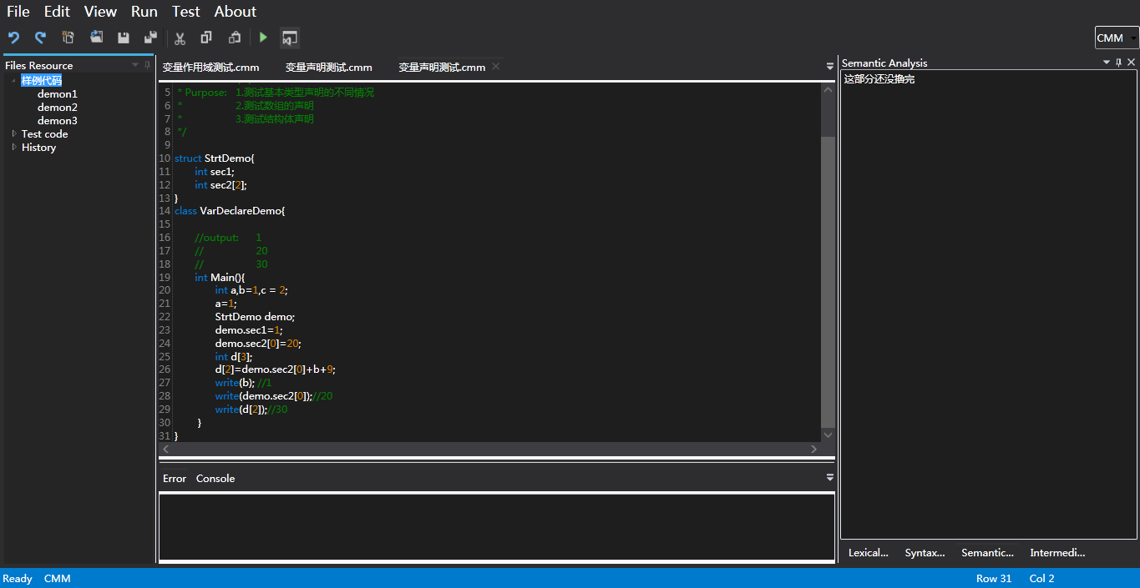

得到如下结果，完成分析过程：

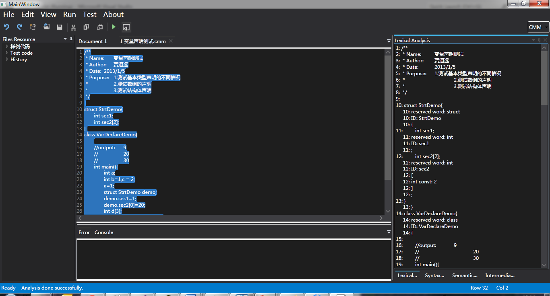

所得到的符号表是：

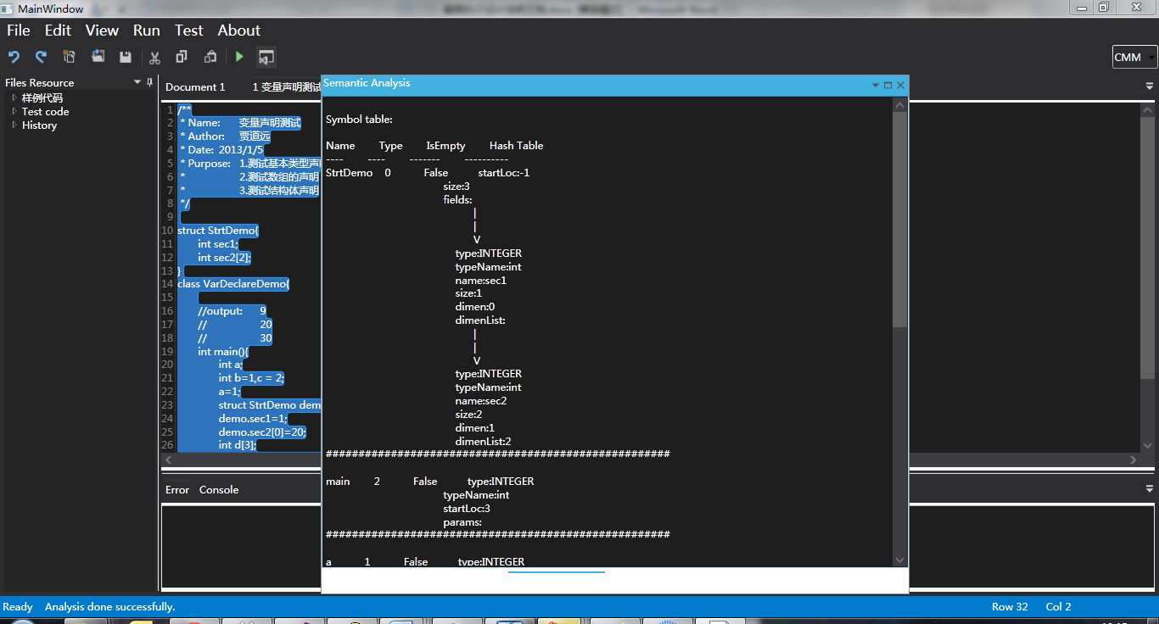

## 4.2 有参数类展示

输入以下内容，得到输入内容和参数输入截图如下：

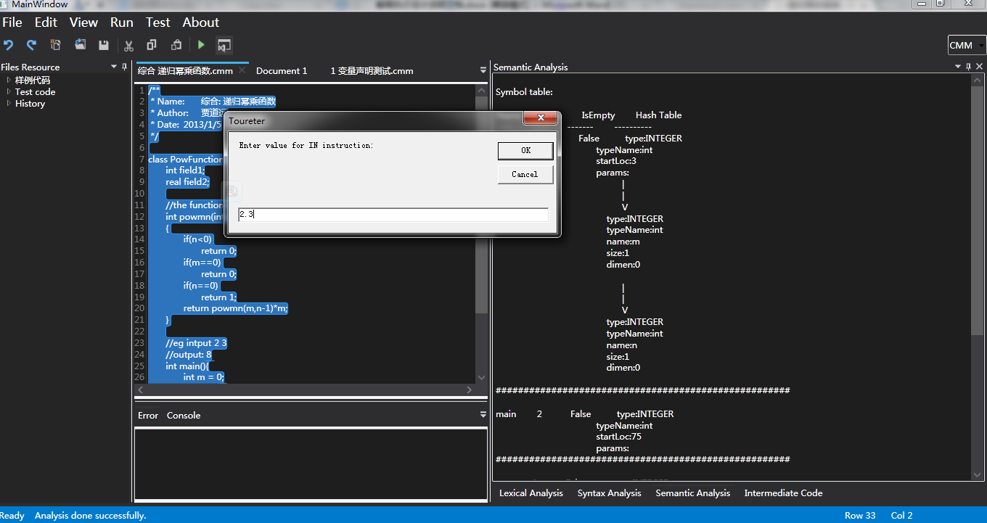

执行结果如下图：

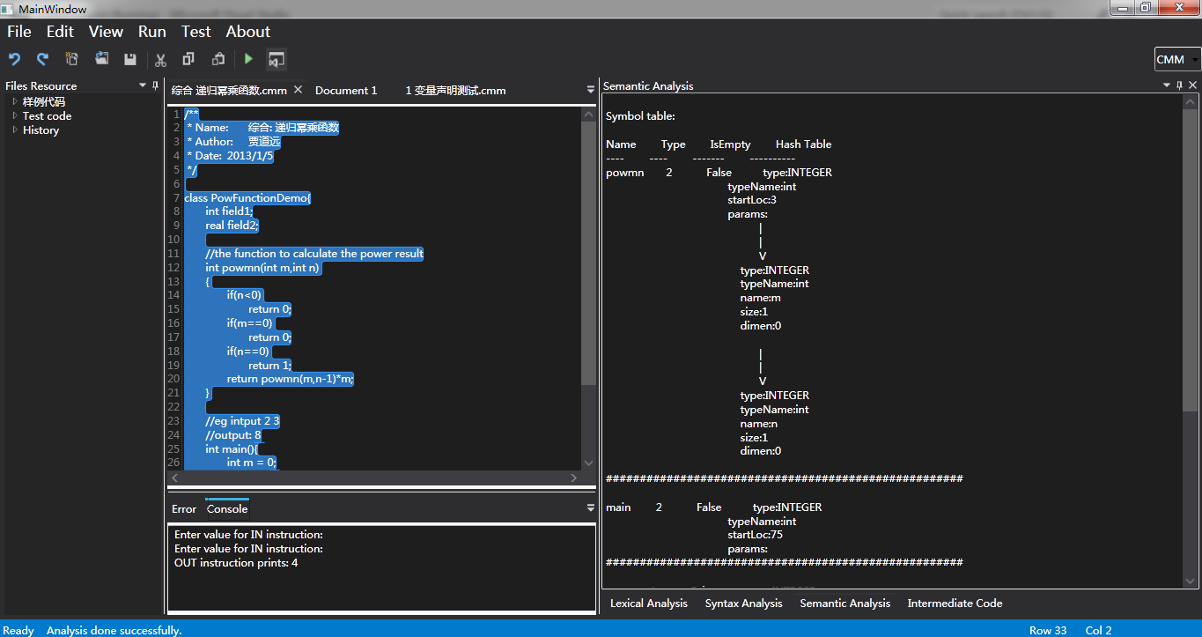

中间代码如下图：

